Castle Hill PSSA Touch Football Draw 2026
Terms 1,3 & 4
Northern Division – Bernie Mullane Reserve/Castle Hill Showground
Beaumont Hills  Kellyville  Glenhaven  Castle Hill | Bella Vista  Sherwood Ridge  Samuel Gilbert  Oakhill Drive

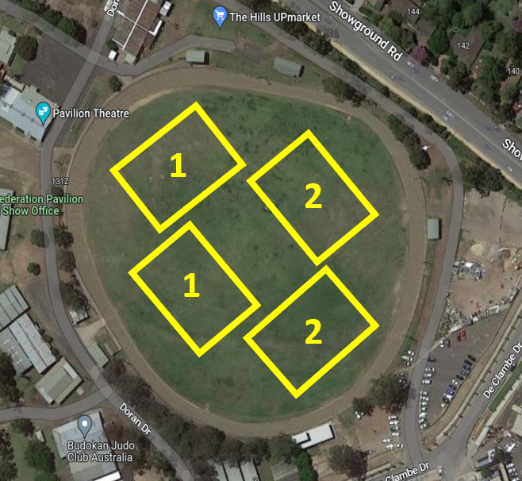
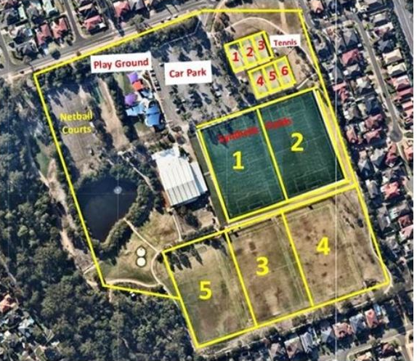

Round 1 – Date 20/2 | VS |  | Field
Beaumont Hills | VS | Samuel Gilbert | 1 - Bernie Mullane
Kellyville | VS | Castle Hill | 2 - Bernie Mullane
Oakhill Drive | VS | Glenhaven | 3- Bernie Mullane
Bella Vista | VS | Sherwood Ridge | 4- Bernie Mullane

Round 2– Date 27/2 | VS |  | Field
Beaumont Hills | VS | Bella Vista | 1 - Bernie Mullane
Oakhill Drive | VS | Kellyville | 2 - Bernie Mullane
Samuel Gilbert | VS | Glenhaven | 3- Bernie Mullane
Castle Hill | VS | Sherwood Ridge | 4- Bernie Mullane

Round 3– Date 6/3 | VS |  | Field
Beaumont Hills | VS | Glenhaven | 1 - Bernie Mullane
Kellyville | VS | Sherwood Ridge | 2 - Bernie Mullane
Oakhill Drive | VS | Bella Vista | 3- Bernie Mullane
Castle Hill | VS | Samuel Gilbert | 4- Bernie Mullane

Term 3
Round 4– Date 21/8 | VS |  | Field
Beaumont Hills | VS | Sherwood Ridge | 1 - Bernie Mullane
Glenhaven | VS | Kellyville | 2 - Bernie Mullane
Oakhill Drive | VS | Samuel Gilbert | 3- Bernie Mullane
Castle Hill | VS | BYE – Bella Vista Camp
Bella Vista | VS | BYE - Camp

Round 5 – 28/8 | VS |  | Field
Beaumont Hills | VS | Castle Hill | 1- Bernie Mullane
Kellyville | VS | BYE - Samuel Gilbert Camp
Samuel Gilbert | VS | BYE - Camp
Oakhill Drive | VS | Sherwood Ridge | 2- Bernie Mullane
Bella Vista | VS | Glenhaven | 3- Bernie Mullane

Round 6 – 4/9 | VS |  | Field
Beaumont Hills | VS | Kellyville | 1- Bernie Mullane
Bella Vista | VS | Samuel Gilbert | 2- Bernie Mullane
Glenhaven | VS | Sherwood Ridge | 3- Bernie Mullane
Oakhill Drive | VS | Castle Hill | 4- Bernie Mullane

Term 4
Round 7 – 16/10 | VS |  | Field
Beaumont Hills | VS | Oakhill Drive | 1- Bernie Mullane
Kellyville | VS | Bella Vista | 2- Bernie Mullane
Sherwood Ridge | VS | Samuel Gilbert | 3- Bernie Mullane
Castle Hill | VS | Glenhaven | 4- Bernie Mullane

Round 8 – 23/10 | VS |  | Field
Beaumont Hills | VS | Bella Vista | 1- Bernie Mullane
Kellyville | VS | Samuel Gilbert | 2- Bernie Mullane
Castle Hill | VS | Oakhill Drive | 3- Bernie Mullane
Glenhaven | VS | Sherwood Ridge | 4 – Bernie Mullane

Round 9 – 30/10 | VS |  | Field
Bella Vista | VS | Castle Hill | 1- Bernie Mullane
Kellyville | VS | Sherwood Ridge | 2- Bernie Mullane
Oakhill Drive | VS | Samuel Gilbert | 3- Bernie Mullane
Glenhaven | VS | Beaumont Hills | 4- Bernie Mullane

Round 10 – 6/11 | VS |  | Field
Oakhill Drive | VS | Kellyville | 1- Bernie Mullane
Castle Hill | VS | Glenhaven | 2- Bernie Mullane
Bella Vista | VS | Samuel Gilbert | 3- Bernie Mullane
Sherwood Ridge | VS | Beaumont Hills | 4- Bernie Mullane

Semi Finals – 13/11
Grand Finals – 20/11

